**Exercise -TraceRoute, ping, ifconfig, ipconfig, netstat**

**Aim:**

Using TraceRoute, ping, ifconfig(LINUX), ipconfig(WINDOWS), and netstat Command.

**Procedure:**

Step 1: open windows command prompt and Type tracert command and type tracert

www.saveetha.com -> “Enter”

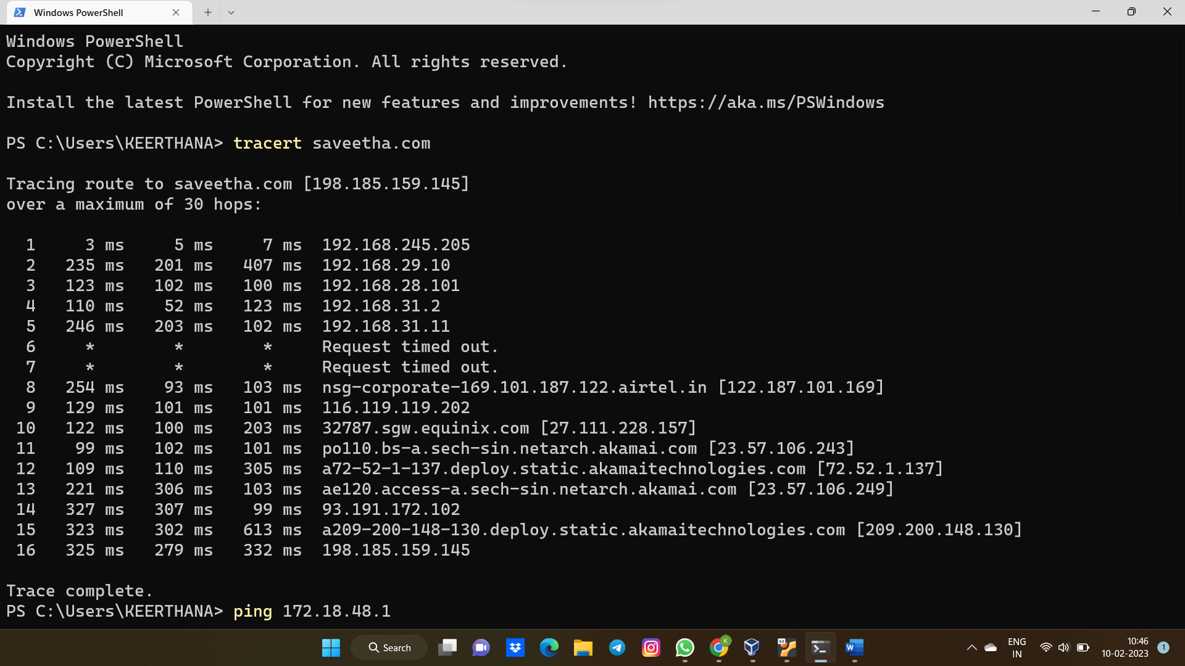

Step 2: Type ping command and type IP Address press “Enter”

Step 3: Type ifconfig command

Step 4: Type netstat command

**Result :**

Hence the Traceroute, ping , ipconfig (LINUX), ipconfig(WINDOWS) and netstat command executed successfully.